Functional Models
“Dual-Relationship Analysis and Recommendation System”
Yashwanth Reddy Anugu, Systems Analyst
February 11, 2026

- Use Case Diagram
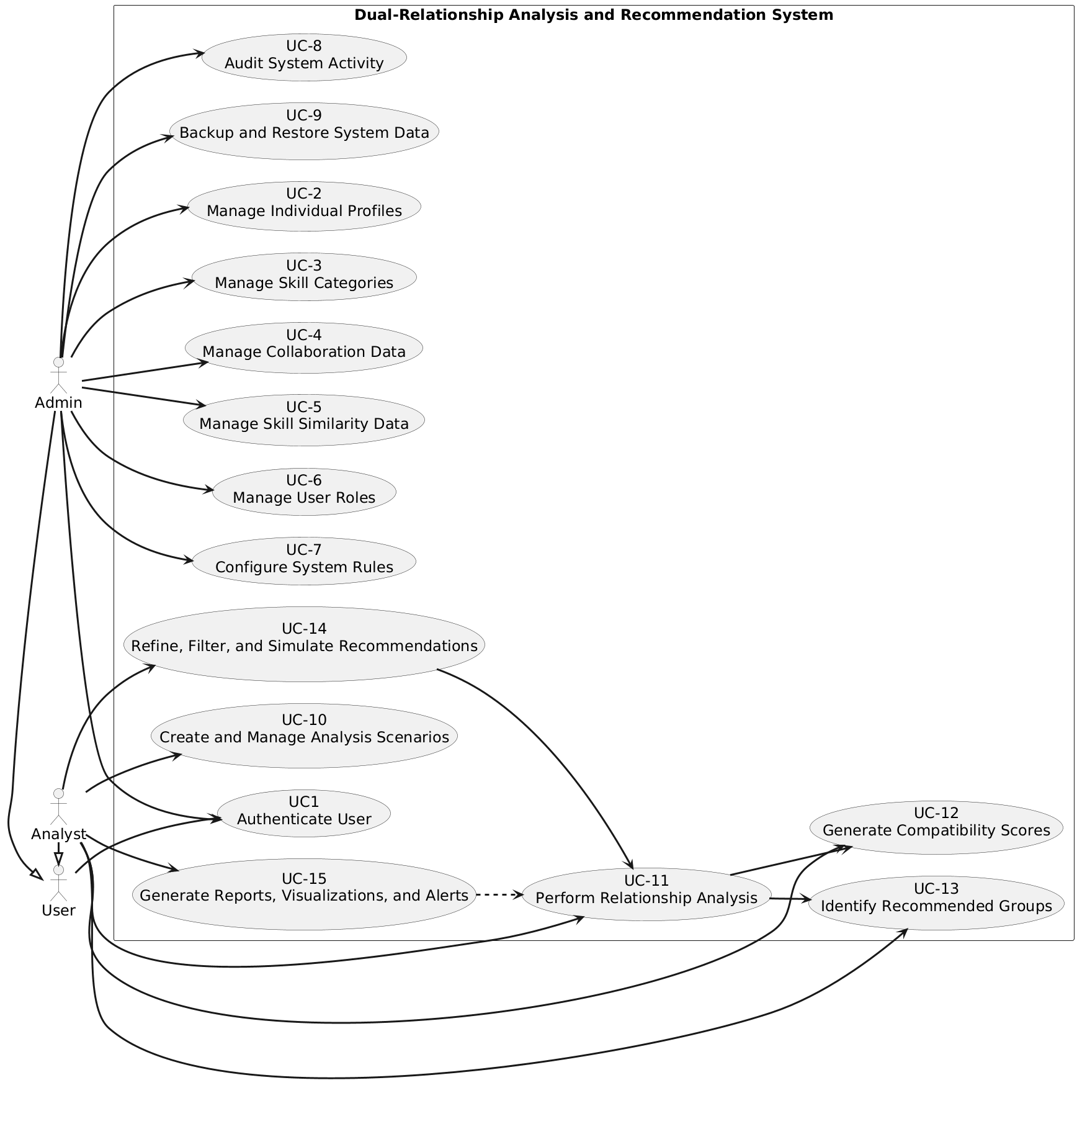
Diagram 1: Use Case Diagram for “Dual-Relationship Analysis and Recommendation System”
- Use Case Description
Use Case - 1
Use Case Name: Authenticate User |  | ID:UC1 | Importance Level: High
Primary Actor: User | Use Case Type: Essential
Stakeholders and Interests: The stakeholders are Users (both Admins and Analysts). Users want secure access to the system so that unauthorized individuals cannot view or manipulate data. Proper authentication protects sensitive collaboration, relationship, and analysis data, ensuring system integrity.
Brief Description: This use case allows a user to log in to the system using valid credentials. It verifies identity before granting access to system functions, including administration, analysis, or scenario management.
Trigger: User initiates the system login by opening the system and entering credentials.
Type: External
Relationships:
Association: Admin, Analyst, User
Include: None
Extend: None
Generalization: Admin → User, Analyst → User
Normal Flow of Events:
- User opens the login page.
- User enters username and password.
- System validates credentials against stored user data.
- System grants access if credentials are correct.
- System displays the home dashboard according to the user’s role.
SubFlows:
S-1: If the user selects “forgot password,” the system initiates the password recovery workflow.
Alternate/Exceptional Flows:
If username or password is invalid, system displays an error message and prompts for re-entry.
If the account is locked due to multiple failed attempts, the system prevents login and alerts the user.

This use case description is covering the requirements – FR-3, FR-30 (Authenticate User).

Use Case - 2
Use Case Name: Manage Individual Profiles |  | ID:UC-2 | Importance Level: High
Primary Actor: Admin | Use Case Type: Operational
Stakeholders and Interests: The stakeholders are Admins who manage user data and Users (Analysts) whose profiles must be accurate. Admins want the ability to create, update, and delete individual profiles so that the system contains correct personal information, skills, and interests. Proper profile management supports accurate relationship analysis and scenario simulations (related Use Case: UC-4 Manage Collaboration Data, UC-5 Manage Skill Similarity Data).
Brief Description: This use case allows Admins to create new individual profiles, update existing profiles, or delete obsolete profiles. Profiles include personal information, skills, and interests.
Trigger: Admin selects the “Manage Individual Profiles” option in the system menu to create, update, or delete a profile.
Type: External
Relationships:
Association: Admin
Include: None
Extend: None
Generalization: None
Normal Flow of Events:
- Admin opens the “Manage Individual Profiles” interface.
- Admin selects an action: Create, Update, or Delete.
- Admin enters or modifies profile data as required.
- System validates the entered data.
- System saves changes and confirms successful operation to Admin.
SubFlows:
S-1: If Admin cancels the operation before completion, system discards changes and returns to the previous screen.
Alternate/Exceptional Flows:
If required fields are missing or invalid, system displays an error and requests correction.
If Admin tries to delete a profile linked to active scenarios (related Use Case: UC-10 Create and Manage Analysis Scenarios), system prevents deletion and displays a warning.

This use case description is covering the requirements – FR-1, FR-2, FR-3 (Manage Individual Profiles).

Use Case - 3
Use Case Name: Manage Skill Categories |  | ID:UC-3 | Importance Level: Medium
Primary Actor: Admin | Use Case Type: Operational
Stakeholders and Interests: The stakeholders are Admins who maintain skill structures in the system and Analysts who rely on accurate skill categorization for relationship analysis (related Use Case: UC-5 Manage Skill Similarity Data, UC-10 Create Analysis Scenario). Admins want to add, update, or delete skill categories to ensure proper classification of individuals’ skills for meaningful analysis and team formation.
Brief Description: This use case allows Admins to define, update, or remove skill categories. Skill categories organize individual skills to support analysis of skill similarity and team compatibility.
Trigger: Admin selects “Manage Skill Categories” in the system menu to create, update, or delete skill categories.
Type: External
Relationships:
Association: Admin
Include: None
Extend: None
Generalization: None
Normal Flow of Events:
- Admin opens the “Manage Skill Categories” interface.
- Admin selects an action: Create, Update, or Delete a category.
- Admin enters or modifies the category name and description.
- System validates the input for uniqueness and correctness.
- System saves changes and confirms the operation to Admin.
SubFlows:
S-1: If Admin cancels the operation before completion, the system discards any changes and returns to the previous screen.
Alternate/Exceptional Flows:
If a category name already exists, system displays an error and prompts Admin to enter a unique name.
If a category is linked to existing profiles, deletion is prevented, and system warns Admin to reassign or remove associated profiles first.

This use case description is covering the requirements – FR-4, FR-5, FR-6 (Manage Skill Categories).

Use Case - 4
Use Case Name: Manage Collaboration Data |  | ID:UC-4 | Importance Level: High
Primary Actor: Admin | Use Case Type: Operational
Stakeholders and Interests: The stakeholders are Admins who maintain historical collaboration records and Analysts who use this data for relationship analysis and team recommendations (related Use Case: UC-11 Perform Relationship Analysis, UC-10 Create Analysis Scenario). Accurate collaboration data ensures proper compatibility scoring and informed group formation decisions.
Brief Description: This use case allows Admins to input, update, or delete historical collaboration data between individuals, ensuring the system has accurate information for analysis and recommendations.
Trigger: Admin selects “Manage Collaboration Data” in the system menu to add, update, or remove collaboration records.
Type: External
Relationships:
Association: Admin
Include: None.
Extend: None
Generalization: None
Normal Flow of Events:
- Admin opens the “Manage Collaboration Data” interface.
- Admin selects an action: Add, Update, or Delete a collaboration record.
- Admin enters or modifies data for the selected individuals and collaboration details.
- System validates the input data for completeness and correctness.
- System saves the changes and confirms the operation to Admin.
SubFlows:
S-1: If Admin cancels the operation before saving, the system discards any changes and returns to the previous screen.
Alternate/Exceptional Flows:
If required fields are missing or incorrect, system displays an error message and requests correction.
If Admin attempts to delete a collaboration record that is referenced in active analysis scenarios (related Use Case: UC-10 Create Analysis Scenario), system prevents deletion and displays a warning.

This use case description is covering the requirements – FR-7, FR-8, FR-9, FR-10, FR-11, FR-12 (Manage Collaboration Data).

Use Case - 5
Use Case Name: Manage Skill Similarity Data |  | ID:UC-5 | Importance Level: High
Primary Actor: Admin | Use Case Type: Operational
Stakeholders and Interests: The stakeholders are Admins who maintain skill similarity scores and Analysts who rely on this data to assess compatibility between individuals (related Use Case: UC-11 Perform Relationship Analysis, UC-10 Create Analysis Scenario). Accurate skill similarity data ensures that the system can generate meaningful team recommendations based on shared skills.
Brief Description: This use case allows Admins to input, update, or delete skill similarity scores between individuals. These scores quantify how closely individuals’ skills align, supporting data-driven analysis and recommendations.
Trigger: Admin selects “Manage Skill Similarity Data” in the system menu to add, update, or remove skill similarity scores.
Type: External
Relationships:
Association: Admin
Include: None
Extend: None
Generalization: None
Normal Flow of Events:
- Admin opens the “Manage Skill Similarity Data” interface.
- Admin selects an action: Add, Update, or Delete a similarity score.
- Admin enters or modifies the similarity score between selected individuals.
- System validates that the scores are numeric and within the allowed range.
- System saves the changes and confirms the operation to Admin.
SubFlows:
S-1: If Admin cancels the operation before saving, the system discards changes and returns to the previous screen.
Alternate/Exceptional Flows:
If input is missing or invalid, system displays an error and requests correction.
If Admin attempts to delete a similarity score that is used in active analysis scenarios (related Use Case: UC-10 Create Analysis Scenario), the system prevents deletion and displays a warning.

This use case description is covering the requirements – FR-13, FR-14, FR-15 (Manage Skill Similarity Data).

Use Case - 6
Use Case Name: Manage User Roles |  | ID:UC-6 | Importance Level: Medium
Primary Actor: Admin | Use Case Type: Operational
Stakeholders and Interests: The stakeholders are Admins who control system access and security, and Analysts who require proper access to perform analyses (related Use Case: UC-1 Authenticate User, UC-10 Create Analysis Scenario). Admins want to assign and revoke roles to ensure users have appropriate permissions for system functions.
Brief Description: This use case allows Admins to assign, update, or revoke user roles such as Analyst or Admin, ensuring the system enforces correct access rights.
Trigger: Admin selects “Manage User Roles” in the system menu to assign or modify roles for users.
Type: External
Relationships:
Association: Admin
Include: None
Extend: None
Generalization: None
Normal Flow of Events:
- Admin opens the “Manage User Roles” interface.
- Admin selects a user to modify roles.
- Admin assigns, updates, or revokes roles.
- System validates that the role changes are permitted.
- System saves the changes and confirms the operation to Admin.
SubFlows:
S-1: If Admin cancels the operation before saving, system discards changes and returns to the previous screen.
Alternate/Exceptional Flows:
If Admin attempts to assign a role that violates system rules (e.g., multiple conflicting roles), system displays an error.
If Admin attempts to revoke their own Admin role, system prevents this action and displays a warning.

This use case description is covering the requirements – FR-29, FR-30 (Manage User Roles).

Use Case - 7
Use Case Name: Configure System Rules |  | ID:UC-7 | Importance Level: Medium
Primary Actor: Admin | Use Case Type: Operational
Stakeholders and Interests: The stakeholders are Admins who define rules for relationship analysis and scoring, and Analysts who rely on these rules to generate meaningful team recommendations (related Use Case: UC-11 Perform Relationship Analysis, UC-10 Create Analysis Scenario). Admins want to set system rules to ensure consistent, accurate, and fair analysis across all scenarios.
Brief Description: This use case allows Admins to create, update, or delete rules that determine how relationships are weighted and how compatibility scores are calculated.
Trigger: Admin selects “Configure System Rules” in the system menu to manage rules for relationship analysis.
Type: External
Relationships:
Association: Admin
Include: None
Extend: None
Generalization: None
Normal Flow of Events:
- Admin opens the “Configure System Rules” interface.
- Admin selects an action: Create, Update, or Delete a rule.
- Admin enters or modifies rule parameters, such as relationship weights or scoring formulas.
- System validates the rule syntax and logical consistency.
- System saves the rules and confirms the operation to Admin.
SubFlows:
S-1: If Admin cancels the operation before saving, system discards any changes and returns to the previous screen.
Alternate/Exceptional Flows:
If rule parameters are invalid or conflict with existing rules, system displays an error and requests correction.
If Admin attempts to delete a rule currently in use in active analysis scenarios (related Use Case: UC-10 Create Analysis Scenario), system prevents deletion and warns Admin.

This use case description is covering the requirements – FR-35, FR-36 (Configure System Rules).

Use Case - 8
Use Case Name: Audit System Activity |  | ID:UC-8 | Importance Level: Medium
Primary Actor: Admin | Use Case Type: Operational
Stakeholders and Interests: The stakeholders are Admins who need to monitor system usage, ensure compliance, and maintain accountability, and Analysts who benefit indirectly by knowing that data integrity is maintained (related Use Case: UC-1 Authenticate User, UC-6 Manage User Roles). Auditing ensures that all system changes and user actions are traceable and secure.
Brief Description: This use case allows Admins to review logs of system activities, including user actions, data modifications, and rule changes, to verify proper use of the system and detect any anomalies.
Trigger: Admin selects “Audit System Activity” in the system menu to review system logs and activity reports.
Type: External
Relationships:
Association: Admin
Include: None
Extend: None
Generalization: None
Normal Flow of Events:
- Admin opens the “Audit System Activity” interface.
- Admin selects filters such as date range, user, or type of activity.
- System retrieves and displays relevant logs.
- Admin reviews the logs and identifies any unusual or unauthorized actions.
- Admin may export logs for reporting or compliance purposes (related Use Case: UC-15 Generate Reports and View Explanations).
SubFlows:
S-1: If Admin cancels the operation before reviewing logs, system closes the interface and returns to the main menu.
Alternate/Exceptional Flows:
If there are no logs matching the selected filters, system displays a “No data found” message.
If Admin does not have proper permissions (related Use Case: UC-6 Manage User Roles), system denies access and displays an error.

This use case description is covering the requirements – FR-31 (Audit System Activity).

Use Case - 9
Use Case Name: Backup and Restore System Data |  | ID:UC-9 | Importance Level: High
Primary Actor: Admin | Use Case Type: Operational
Stakeholders and Interests: The stakeholders are Admins responsible for safeguarding system data, and Analysts who depend on accurate and available data for analysis (related Use Case: UC-1 Authenticate User, UC-10 Create Analysis Scenario, UC-11 Perform Relationship Analysis). Backups ensure that all user profiles, relationship data, scenarios, and rules can be recovered in case of accidental deletion or corruption.
Brief Description: This use case allows Admins to back up all system data and restore it when necessary to prevent data loss and maintain system integrity.
Trigger: Admin selects “Backup and Restore System Data” in the system menu to create a backup or restore previously saved data.
Type: External
Relationships:
Association: Admin
Include: None
Extend: None
Generalization: None
Normal Flow of Events:
- Admin opens the “Backup and Restore System Data” interface.
- Admin chooses either “Backup Data” or “Restore Data.”
- For backup, system saves all relevant data to a secure location.
- For restore, Admin selects a backup file, and the system restores all data.
- System confirms the completion of backup or restore operations.
SubFlows:
S-1: If Admin cancels the operation before completion, system aborts the process and returns to the previous screen.
Alternate/Exceptional Flows:
If backup storage is unavailable or full, system displays an error and requests a valid location.
If the selected restore file is corrupt or incompatible, system aborts the restore and displays an error.
If Admin lacks permission (related Use Case: UC-6 Manage User Roles), system denies access and displays a warning.

This use case description is covering the requirements – FR-40, FR-11, FR-12, FR-15 (Backup and Restore System Data).

Use Case - 10
Use Case Name: Create and Manage Analysis Scenarios |  | ID:UC-10 | Importance Level: High
Primary Actor: Analyst | Use Case Type: Operational
Stakeholders and Interests: The stakeholders are Analysts who need to define and explore multiple team formation scenarios, and Admins who provide the rules and data used in the analyses (related Use Case: UC-2 Manage Individual Profiles, UC-4 Manage Collaboration Data, UC-7 Configure System Rules). Analysts benefit from being able to test different configurations and weights to generate the most effective teams.
Brief Description: This use case allows Analysts to create, modify, and save analysis scenarios. Each scenario defines which individuals are included, assigns relationship weights, and configures optional parameters that influence team recommendations.
Trigger: Analyst selects “Create and Manage Analysis Scenarios” in the system interface to start a new scenario or modify an existing one.
Type: External
Relationships:
Association: Analyst
Include: None
Extend: None
Generalization: None
Normal Flow of Events:
- Analyst opens the “Create and Manage Analysis Scenarios” interface.
- Analyst selects individuals to include in the scenario.
- Analyst assigns relationship weights and adjusts optional configuration parameters.
- Analyst saves the scenario with a unique name for future use.
- System confirms that the scenario has been successfully saved or updated.
SubFlows:
S-1: If Analyst cancels before saving, system discards all changes and returns to the main menu.
Alternate/Exceptional Flows:
If Analyst tries to save a scenario with a duplicate name, system prompts for a unique name.
If selected individuals or weights are invalid (related Use Case: UC-2 Manage Individual Profiles, UC-4 Manage Collaboration Data), system displays an error message.
If system storage fails during save, system notifies the Analyst and aborts the operation.

This use case description is covering the requirements – FR-16, FR-17, FR-24, FR-25, FR-26 (Create and Manage Analysis Scenarios).

Use Case - 11
Use Case Name: Perform Relationship Analysis |  | ID:UC-11 | Importance Level: High
Primary Actor: Analyst | Use Case Type: Operational
Stakeholders and Interests: The stakeholders are Analysts who want to evaluate potential team formations and Admins who provide system rules and validated data (related Use Case: UC-7 Configure System Rules, UC-10 Create and Manage Analysis Scenarios, UC-12 Generate Compatibility Scores, UC-13 Identify Recommended Groups). Analysts benefit by receiving data-driven recommendations for forming strong, compatible teams.
Brief Description: This use case allows Analysts to perform a relationship analysis using previously defined scenarios. The system calculates compatibility scores and identifies strongly connected groups of individuals, producing the foundational data for team recommendations.
Trigger: Analyst selects a scenario and initiates relationship analysis to evaluate team compatibility.
Type: External
Relationships:
Association: Analyst
Include: UC-12 Generate Compatibility Scores, UC-13 Identify Recommended Groups
Extend: None
Generalization: None
Normal Flow of Events:
- Analyst selects a saved analysis scenario from the system.
- System validates that all required data and scenario parameters are present.
- System applies relationship weights and rules (from UC-7 Configure System Rules) to compute compatibility scores.
- System identifies strongly connected groups of individuals based on computed scores.
- System stores the results for further exploration, refinement, or reporting.
SubFlows:
S-1: If scenario data is incomplete, system prompts the Analyst to correct it before proceeding.
Alternate/Exceptional Flows:
If no compatible groups are identified, system alerts the Analyst and suggests adjusting relationship weights or scenario parameters.
If computation fails due to a system error, system notifies the Analyst and logs the issue.
If selected individuals are invalid (related Use Case: UC-2 Manage Individual Profiles, UC-4 Manage Collaboration Data), system displays an error.
This use case description is covering the requirements – FR-16, FR-17, FR-18, FR-19, FR-20, FR-21, FR-22, FR-32, FR-33 (Perform Relationship Analysis).
Use Case – 12
Use Case Name: Generate Compatibility Scores |  | ID:UC-12 | Importance Level: High
Primary Actor: Analyst | Use Case Type: Operational
Stakeholders and Interests: The stakeholders are Analysts who need quantitative metrics to assess the strength of relationships among individuals, and Admins who ensure that the relationship rules and data are accurate (related Use Case: UC-2 Manage Individual Profiles, UC-4 Manage Collaboration Data, UC-5 Manage Skill Similarity Data). Analysts benefit from clear, actionable scores that guide team formation decisions.
Brief Description: This use case allows the system to compute compatibility scores between individuals based on the scenario parameters and relationship weights defined by the Analyst. These scores form the foundation for identifying recommended groups.
Trigger: Analyst initiates “Generate Compatibility Scores” after selecting an analysis scenario.
Type: Internal
Relationships:
Association: Analyst
Include: None
Extend: None
Generalization: None
Normal Flow of Events:
- Analyst selects an analysis scenario to evaluate.
- System retrieves individual data, collaboration history, and skill similarity metrics.
- System applies defined rules and weights to calculate compatibility scores between all relevant individuals.
- System stores compatibility scores in the scenario results for use in identifying recommended groups.
SubFlows:
S-1: If certain individual data is missing or inconsistent, system flags the data for Analyst review and continues calculation with valid entries.
Alternate/Exceptional Flows:
If calculation fails due to missing relationship rules (related Use Case: UC-7 Configure System Rules), system alerts the Analyst.
If computational error occurs, system notifies the Analyst and logs the issue.
If invalid scenario parameters are detected (related Use Case: UC-10 Create and Manage Analysis Scenarios), system prompts Analyst to correct them.

This use case description is covering the requirements – FR-17, FR-18 (Generate Compatibility Scores).

Use Case - 13
Use Case Name: Identify Recommended Groups |  | ID:UC-13 | Importance Level: High
Primary Actor: Analyst | Use Case Type: Operational
Stakeholders and Interests: The stakeholders are Analysts who want actionable recommendations for forming effective teams, and Admins who ensure relationship data and scoring rules are accurate (related Use Case: UC-11 Perform Relationship Analysis, UC-12 Generate Compatibility Scores, UC-2 Manage Individual Profiles, UC-4 Manage Collaboration Data, UC-5 Manage Skill Similarity Data). Analysts benefit by receiving pre-formed groups of individuals based on computed compatibility scores, reducing manual effort and improving decision-making.
Brief Description: This use case allows the system to identify and suggest groups of individuals who are strongly connected and compatible based on previously calculated compatibility scores. Recommended groups can be further refined, filtered, or exported for reporting.
Trigger: Analyst initiates “Identify Recommended Groups” after generating compatibility scores.
Type: Internal
Relationships:
Association: Analyst
Include: None
Extend: None
Generalization: None
Normal Flow of Events:
- Analyst selects a scenario with computed compatibility scores.
- System retrieves the compatibility scores for all individuals in the scenario.
- System applies grouping logic and rules (from UC-7 Configure System Rules) to identify strongly connected groups.
- System presents recommended groups to the Analyst for review, refinement, or reporting.
SubFlows:
S-1: If certain individuals lack sufficient data for scoring (related Use Case: UC-2 Manage Individual Profiles, UC-4 Manage Collaboration Data), system flags them and excludes them from the current grouping calculation.
Alternate/Exceptional Flows:
If no compatible groups are identified, system alerts the Analyst and suggests adjusting scenario parameters or weights (related Use Case: UC-10 Create and Manage Analysis Scenarios, UC-14 Refine, Filter, and Simulate Recommendations).
If system encounters calculation errors, it notifies the Analyst and logs the issue.
If selected scenario is invalid or incomplete, system prompts the Analyst to select a valid scenario (related Use Case: UC-10 Create and Manage Analysis Scenarios).
This use case description is covering the requirements – FR-19, FR-20, FR-21 (Identify Recommended Groups).
Use Case - 14
Use Case Name: Refine, Filter, and Simulate Recommendations |  | ID:UC-14 | Importance Level: High
Primary Actor: Analyst | Use Case Type: Operational
Stakeholders and Interests: The stakeholders are Analysts who want to explore alternative team formations, simulate potential collaborations, and filter recommendations to find optimal groupings, and Admins who ensure system rules and data are accurate (related Use Cases: UC-11 Perform Relationship Analysis, UC-12 Generate Compatibility Scores, UC-13 Identify Recommended Groups, UC-10 Create and Manage Analysis Scenarios, UC-7 Configure System Rules). Analysts benefit by being able to test scenarios before finalizing decisions and make informed, data-driven recommendations.
Brief Description: This use case allows the Analyst to refine recommended groups, apply filters based on skills or collaboration history, and simulate different collaboration scenarios to predict compatibility outcomes.
Trigger: Analyst initiates “Refine, Filter, and Simulate Recommendations” after receiving initial recommended groups.
Type: External
Relationships:
Association: Analyst
Include: UC-11 Perform Relationship Analysis
Extend: None
Generalization: None
Normal Flow of Events:
- Analyst selects an initial set of recommended groups from UC-13 Identify Recommended Groups.
- Analyst applies filters such as skills, past collaborations, or interest similarity.
- Analyst adjusts scenario parameters or relationship weights to refine groupings.
- Analyst runs simulations to predict collaboration outcomes based on refined criteria.
- System presents updated group recommendations and compatibility insights for review.
SubFlows: S-1: If the simulation encounters missing or incomplete data (related Use Cases: UC-2 Manage Individual Profiles, UC-4 Manage Collaboration Data, UC-5 Manage Skill Similarity Data), system flags the missing data and allows Analyst to update the scenario before proceeding.
Alternate/Exceptional Flows: If no compatible groups are found after refinement, system notifies Analyst and suggests modifying scenario parameters or weights (related Use Cases: UC-10 Create and Manage Analysis Scenarios, UC-7 Configure System Rules).
If the system detects conflicting parameter inputs during simulation, it alerts the Analyst to resolve the conflicts.
If system encounters processing errors during simulation, it logs the issue and informs the Analyst.
This use case description is covering the requirements – FR-20, FR-22, FR-33 (Refine, Filter, and Simulate Recommendations).
Use Case - 15
Use Case Name: Generate Reports, Visualizations, and Alerts |  | ID:UC-15 | Importance Level: High
Primary Actor: Analyst | Use Case Type: Operational
Stakeholders and Interests: The stakeholders are Analysts who need to view, export, and share the results of analysis in clear formats, and Admins who ensure system data integrity and proper access control (related Use Cases: UC-11 Perform Relationship Analysis, UC-12 Generate Compatibility Scores, UC-13 Identify Recommended Groups, UC-14 Refine, Filter, and Simulate Recommendations). Analysts benefit by producing actionable insights, visual summaries, and notifications to support decision-making and collaboration.
Brief Description: This use case allows the Analyst to generate reports in PDF or CSV formats, create visual network diagrams of relationships, and receive alerts about conflicts, weak connections, or other noteworthy findings from the analysis.
Trigger: Analyst initiates “Generate Reports, Visualizations, and Alerts” after completing analysis and reviewing recommendations.
Type: External
Relationships:
Association: Analyst
Include: None
Extend: UC-11 Perform Relationship Analysis
Generalization: None
Normal Flow of Events:
- Analyst selects the desired output: report, visualization, or alert notifications.
- System generates a detailed report with recommendations, compatibility scores, and scenario results.
- System creates visual network diagrams showing relationships among individuals.
- System identifies conflicts, weak connections, or important insights and issues alerts.
- Analyst reviews, saves, or exports the generated outputs.
SubFlows: S-1: If certain data is missing or incomplete (related Use Cases: UC-2 Manage Individual Profiles, UC-4 Manage Collaboration Data, UC-5 Manage Skill Similarity Data), system flags the missing data and suggests updates before generating reports or visualizations.
Alternate/Exceptional Flows:
If the report or visualization cannot be generated due to system errors, system notifies Analyst and logs the issue.
If export fails (e.g., PDF or CSV), system prompts Analyst to retry or save to a different location.
If alerts are triggered but cannot be delivered (e.g., notification system unavailable), system logs the alerts for later review.
This use case description is covering the requirements – FR-23, FR-27, FR-28, FR-34, FR-39 (Generate Reports, Visualizations, and Alerts).
2. Activity Diagram
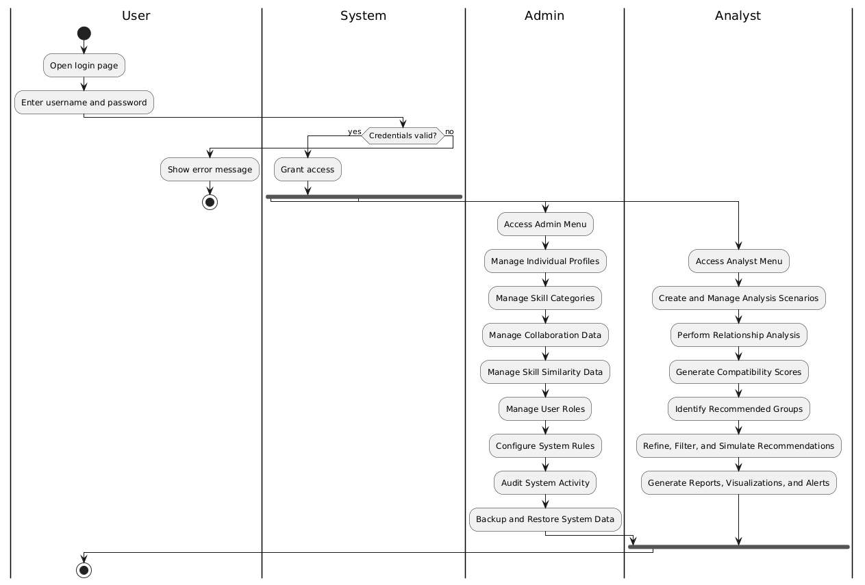
Diagram 2: Activity Diagram for “Dual-Relationship Analysis and Recommendation System”

